Lab W3D3

Qusetion 1. Induced Graphs. Answer questions about the graph G = (V,E) displayed below.
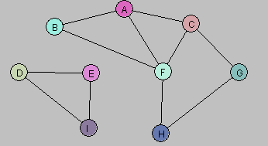

- Let U = {A, B}. Draw G[U].
- Let W = {A, C, G, F}. Draw G[W].
- Let Y = {A, B, D, E}. Draw G[Y].
- Consider the following subgraph H of G:
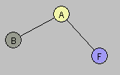
Is there a subset X of the vertex set V so that H = G[X]? Explain.
- Find a way to partition the vertex set V into two subsets V₁, V₂ so that each of the induced graphs G[V₁] and G[V₂] is connected and G = G[V₁] U G[V₂].

Question 2. The following graph has a Hamiltonian cycle. Find it.

